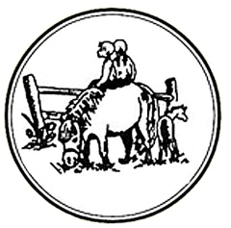
Maryland Pony Breeders
Annual Meeting & Awards Banquet
Sunday January 20th, 2019
11am-2 pm
Broken Spoke Winery
(owned by Rob & Thea Hall)
942 Glebe Rd
Earlsville, Maryland 21919
PLEASE RESPOND BY JANUARY 5TH. WE NEED A COUNT

Adults: $30 (Wine & Mimosas Included)
Children 3-10: $15
Total Number of tickets: _________ Total Amount: ___________

Please list names of those attending__________________________________________

Send checks payable to MPB Inc. to:
MPB
c/o Becci Hall
1003 Redbrook Court
Bel Air, MD 21014
beccihall66@gmail.com
410-688-0787
Silent Auction Items Needed –Funds raised from the auction are used for the Futurity
For silent auction information, please contact Susie Weigand poniesrule2001@yahoo.com
Tentative Brunch Schedule
11:00 – 11:30 Registration & Silent Auction Start
11:30 – 12:30 Brunch
12:30 – 1:00 Annual Meeting
1:30 - Silent Auction ends
1:00 – 2:00 Awards

